**Brilliant Student VS Zombie Professors Protocol Definition**

Overview

This document contains part of the protocol definitions for the Brilliant Students vs Zombie Professors game. The system has many different agents (processes) that need to communicate with each other. The defined protocols are only those involve the Brilliant Students (BS), Whining Twine Generators (WG), and the Excuse Generators (EG).

Communication Patterns

Figure 1: Successful Request-Reply Conversation

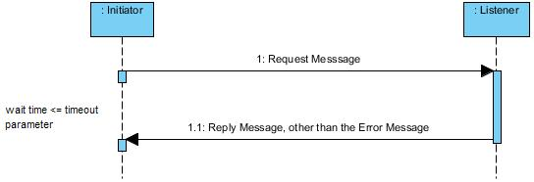

Figure 2:Timeout Request-Reply

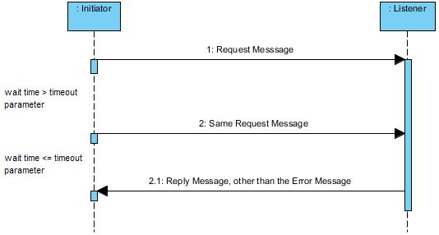

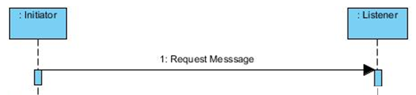

Figure 3:Request without response

Conversations

**Table 1 : All of the conversations with descriptions**

|  |  |  |  |  |  |  |
| --- | --- | --- | --- | --- | --- | --- |
| **Conversation** | **Initiator** | **Receiver** | **Type** | **Request Message** | **Response Message** | **Description** |
| Register | BS,WG,  EG | Game | Request/Response | Register | Ack | Register with the playing field and be placed |
| Move | BS | Playing Field | Request/Response | Move | Ack | Move |
| Throw Bomb | BS | Playing Field | Request/Response | Bomb | Ack | throw a bomb on the field |
| Clock Tick | Clock Tower | BS,WG,  EG | Request | TimeTick | N/A | clockTower sends everyone a time tick |
| GetField | BS | Game | Request/Response | FieldReq | FieldRes | Bs asks for the Playing Field |
| getParams | ANY | Game | Request/Response | ParamReq | ParamRes | Get the current Parameters |
| GetLayout | BS | Playing Field | Request/Response | LayoutReq | LayoutRes | Get the layout of the ground(grass/sidewalk) |
| getAgents | BS | Playing Field | Request/Response | AgentReq | AgentRes | Get information about agents (BS,WG,EG,ZP) |
| getMaterial | BS | WG,EG | Request/Response | WineReq|  TwineReq | WhineRes|  TwineRes | Get an excuse or twine from the generator |
| GetTarget | BS | BS | Request/Response | TargetReq | TargetRes | Get the ZP the other BS is currently targeting |
| DecreaseHealth | Playing Field | BS,EG,WG | Request | DecreaseHealth | N/A | Notify agent that it is being eaten/killed |

Figure 4:Message Hierarchy

